Week 1

S.E=std of error of mean is less than the pop std ,because we expect the means of sampling dist to be less variable than the pop

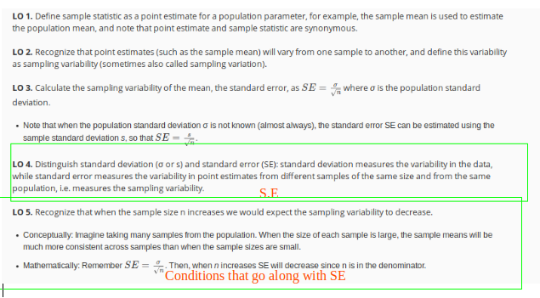
https://gallery.shinyapps.io/CLT_mean/
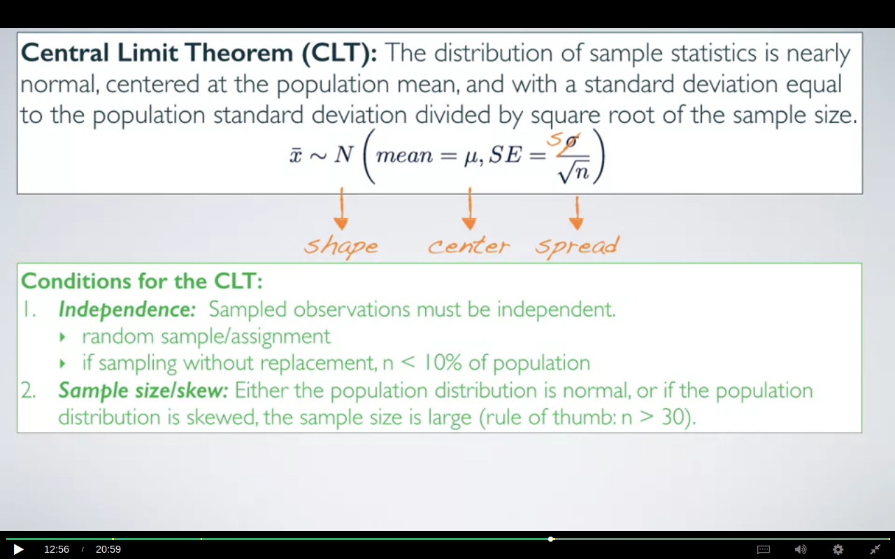
THE SECOND CONDITION HERE IS AT MOST 10% AND NOT ATLEAST 10%

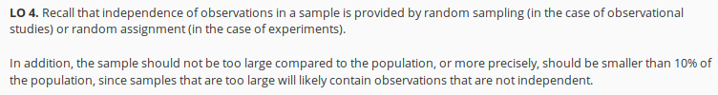

if the pop dist is normal then the sampling dist is also going to be normal regardless of the sample size however if it is not then we would have to take the sample size>= 30. the more skewed a dist is the larger the s.s will be needed in order to follow the CLT.

Often times We do not know what dist our population is following,so for those scenarios we plot our sample data and assume that both follow the same dist.

We need to concentrate on sample dist before doing any calculations ,for instance the dist of the
incomes can’t be the normal as there’s no certain limit to what a person can earn.

CASE STUDY FOR SAMPLE DIST: AVG INTAKE OF SNACKS OF DISTRACTED EATERS.
Suppose The sample mean is 52 and sd=45.1gm there's a natural boundary at 0 since one cannot eat less than 0 grams of biscuit. So the 68, 95, 99.7 rule is just not going to apply here. Because if we were go more than one standard deviation below the mean, we're going to hit that natural boundary of 0 grams. Therefore that data are likely right skipped

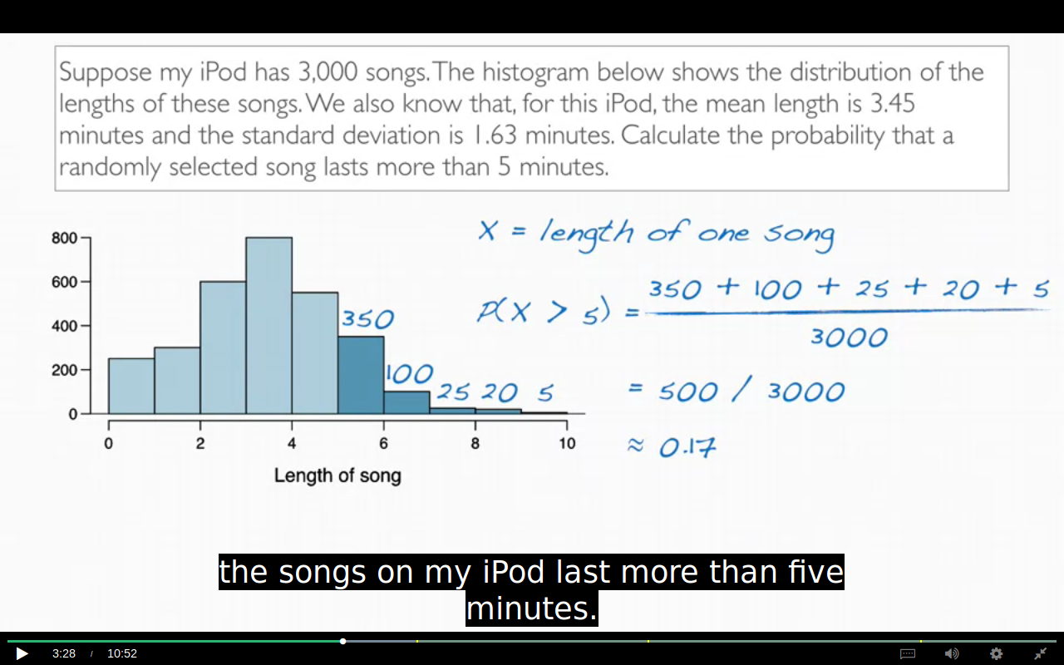
The methods for calculating the prop using Z table can;t be applied here as the dist is right skewed.

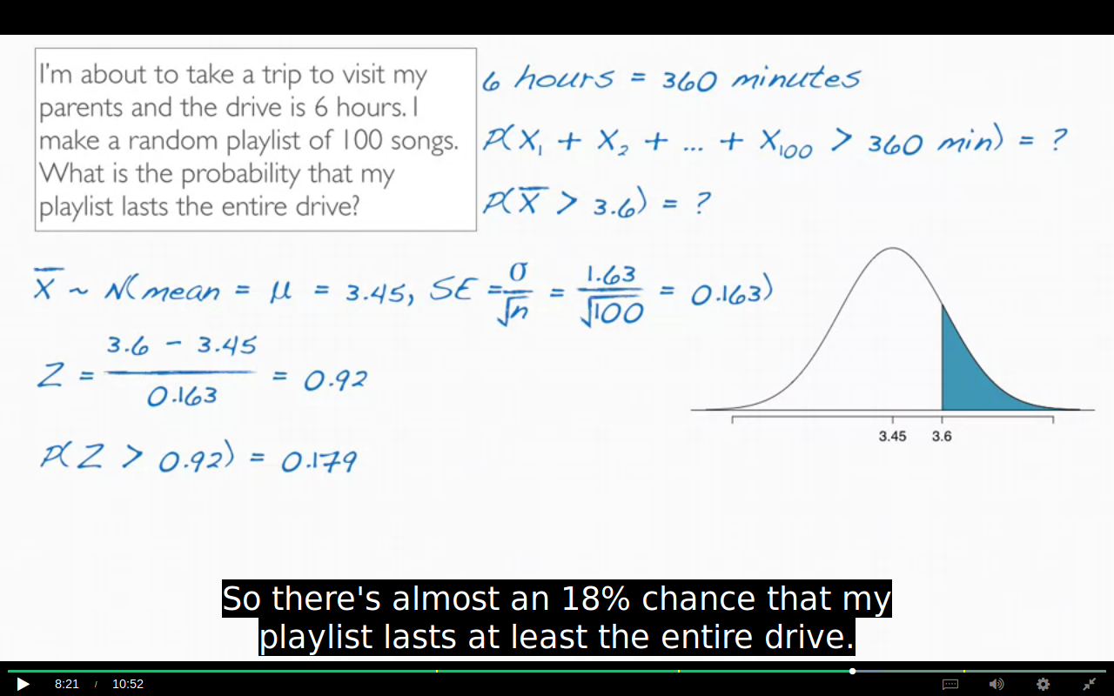

Think why this is true ?
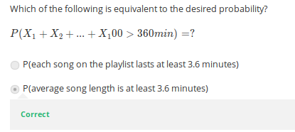

Q. When do I use sigma /sqrt(n)?
A. You always divide by sqrt(n). However, occasionally the square root of n sometimes equals 1 (making it just σ in the denominator. for example, if you are choosing one person and trying to figure out the probability their weight is under x pounds, then n=1. In other words, if you are calculating a z-score, you can always use √(n).
We measure the variability of individual observations with standard deviations. We measure the variability of sample means with standard errors.So whatever the observation is that you plug in in
the numerator in your Z-score, its variability belongs in the denominator.
In other words, our observation is an X bar, and not an X.

CONFIDENCE INTERVAL:
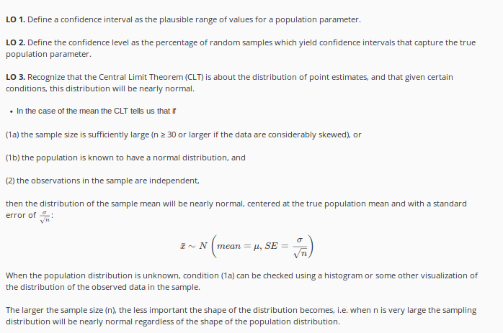
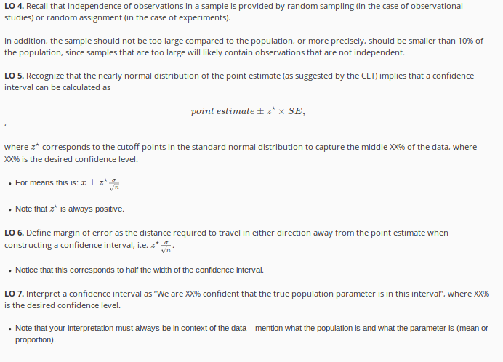

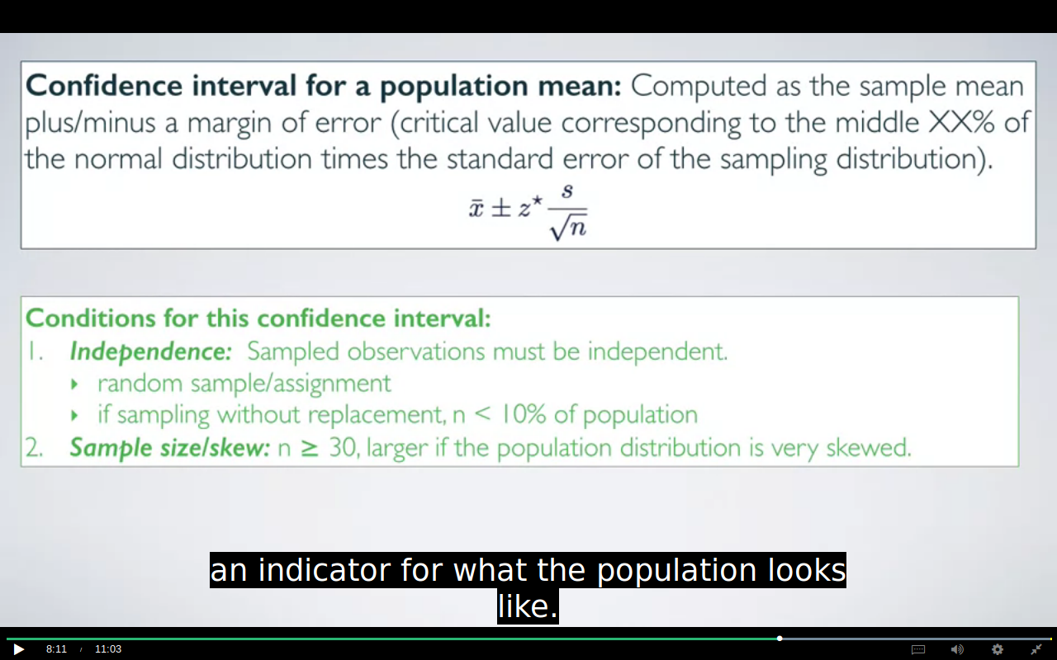
THE CONDITIONS ARE SAME AS OF CLT BUT THE SECOND IS MORE STRICT HERE
THE SECOND CONDITION HERE IS AT MOST 10% AND NOT ATLEAST 10%

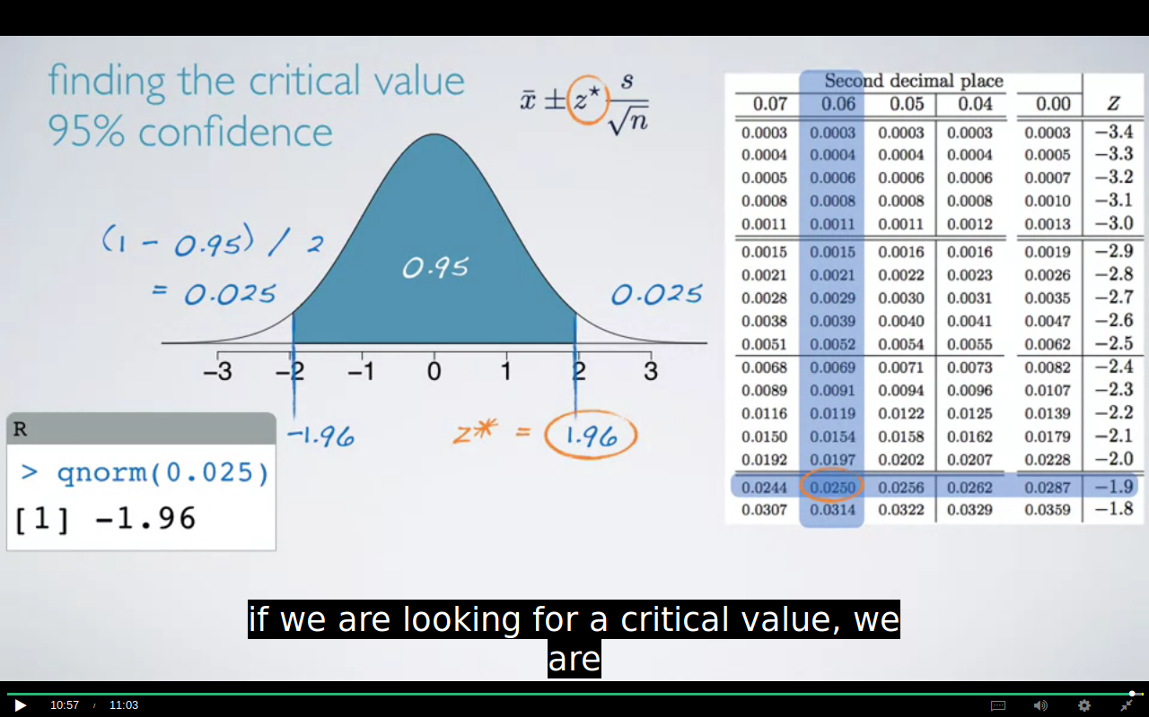

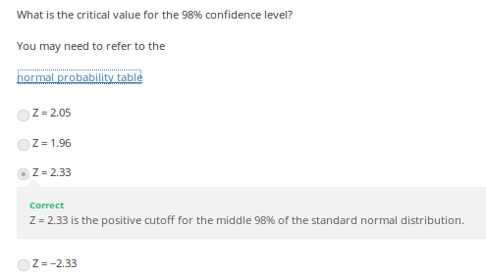

Given that the critical value for a 95% confidence interval is 1.96, for a 98% confidence interval is 2.33, and for a 99% confidence interval is 2.58, what happens to the width of the confidence interval as the confidence level increases (all else held constant)?
As the confidence level increases the interval gets wider.
Correct
The higher the confidence level, the larger the critical value, hence the larger the margin of error, and hence the width of the confidence interval.
As the confidence level increases the interval gets narrower.
As the accuracy increases the precision decreases

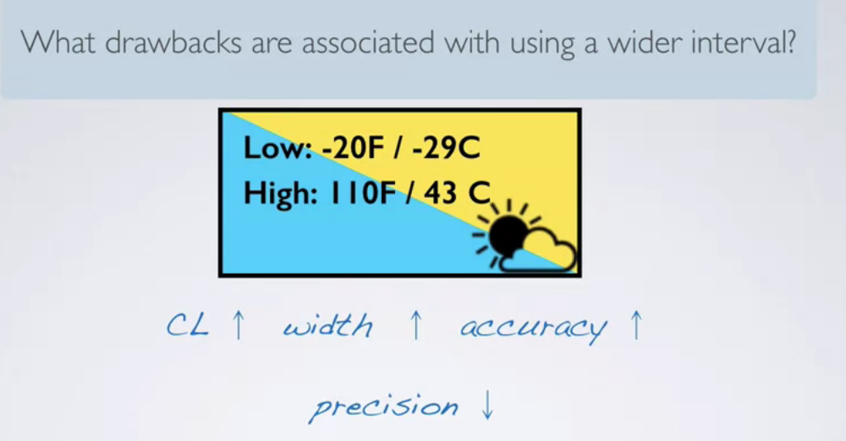

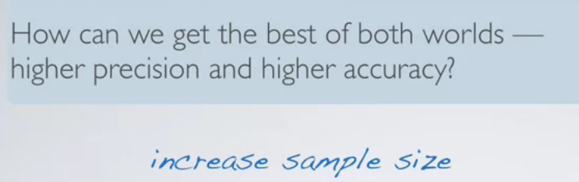
as we increase our sample size the SE decreases and hence our precision will not decrease drastically.

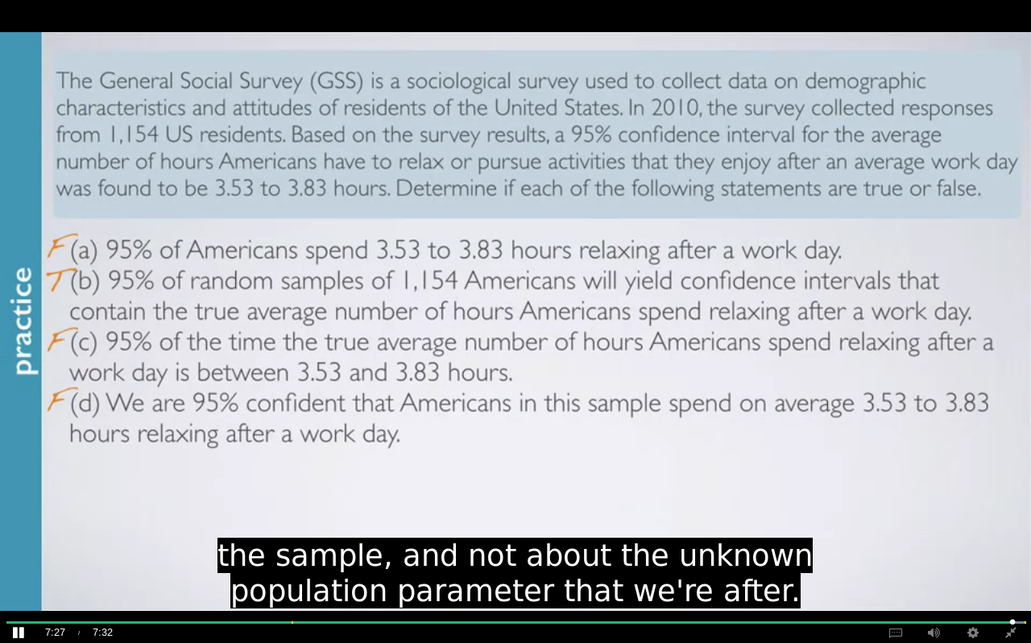
MOST IMPORTANT PART

A says that 95% of Americans spend between
3.53 to 3.83 hours relaxing after a work day.
This is not true because remember that the confidence interval is not about
individuals in the population but instead about the true population parameter.
B says that 95% of random samples of 1,154 Americans(and not one individual)
will yield confidence intervals that contain the true average
number of hours Americans spend relaxing after a work day.
This is indeed the definition of the confidence level.
The percentage of random samples that will yield confidence intervals
that contain the true population parameter.
So this is true.
C says 95% of the time the true average
number of hours Americans spend relaxing after
a work day is between 3.53 and 3.83 hours.
This is not true because the population parameter is not this moving target
that is sometimes within an interval and sometimes outside of it.

And lastly, D says we are 95% confident that Americans in this sample
spend on average 3.53 to 3.83 hours relaxing after a work day.

This is not true because remember that the confidence interval
is not about the sample mean, but is instead about the population mean.
We know exactly what the sample mean is.
It has to be between these values because we construct the confidence interval
around the sample mean.
Therefore, we could actually say that we are 100% confident that Americans
in this sample spend on average between 3.53 and
3.83 hours relaxing after an average work day.

EXAMPLE:

The General Social Survey (GSS) is a sociological survey used to collect data on demographic characteristics and attitudes of residents of the United States. In 2010, the survey collected responses from 1,154 US residents. Based on the survey results, a 95% confidence interval for the average number of hours Americans have to relax or pursue activities that you enjoy after an average work day is 3.53 to 3.83 hours. Which of the following is false?
Increasing the confidence level would result in a more accurate but less precise confidence interval.
The standard error is approximately 0.075 hours.
The sample mean is 3.68 hours.
The margin of error is 0.3 hours.
Correct
The margin of error is (3.83 – 3.53) / 2 = 0.3 / 2 = 0.15 hours.

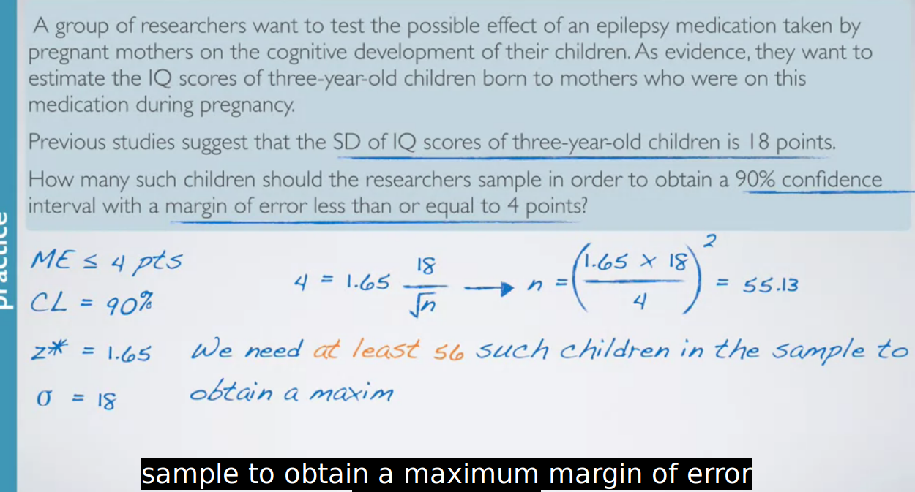
Since 55..13 was minimum we will round it to 56

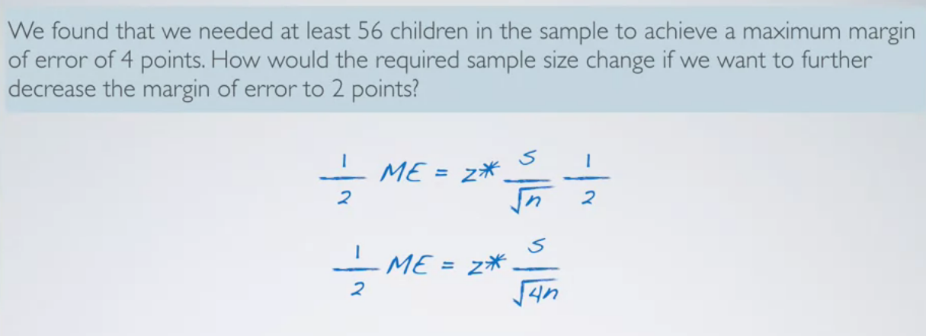
the reation between n and me is inverse and exponential as well as we have to take the square of the number by which we want our me to be decreased.

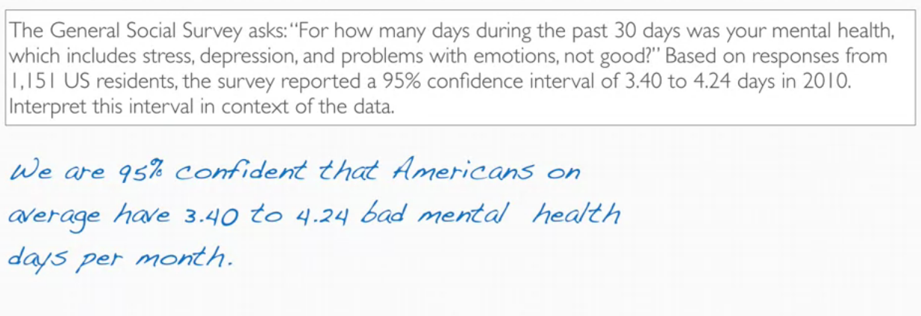

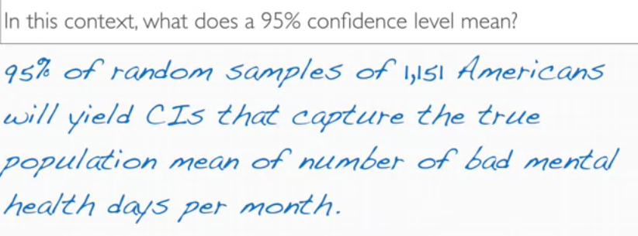

Which of the following is a condition that needs to be met to calculate a confidence interval for a population mean using methods that rely on the Central Limit Theorem?
A) The population distribution must be nearly normal.
B) At least 10% of the population must be sampled.
C) The sampled observations must be independent with respect to the variable in question.
Correct
The population distribution does not necessarily need to be nearly normal, as the CLT will hold if the sample size is large even if the population distribution is skewed. At most, not at least, 10% of the population must be sampled. The success-failure condition is useful for categorical variables, not numerical. So the only choice that is correct is “The sampled observations must be independent with respect to the variable in question.”
D) There should be at least 10 successes and 10 failures

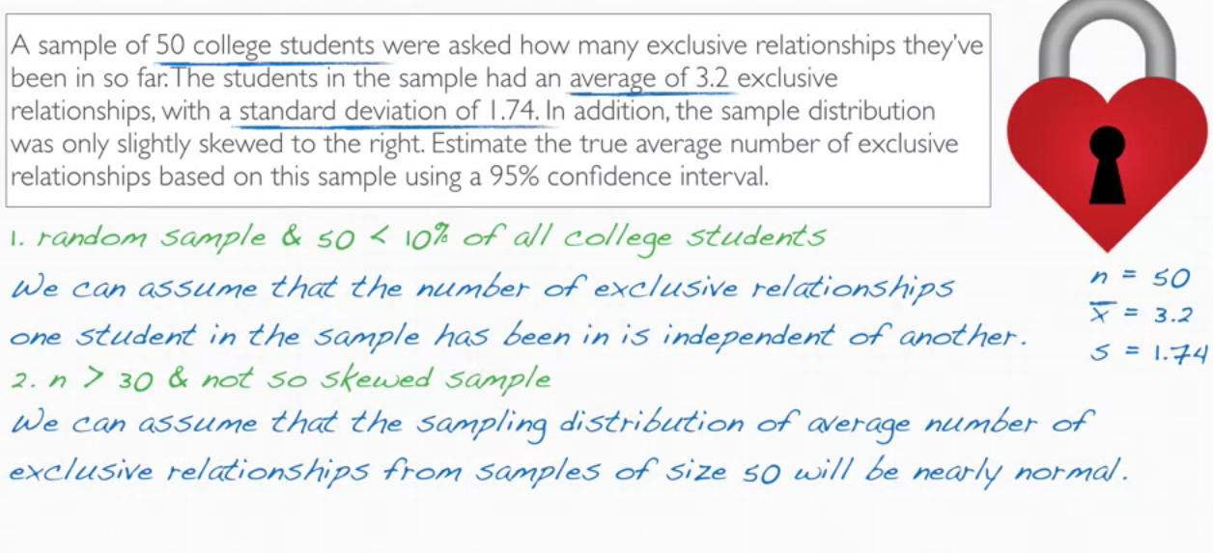
WEEK 2
HYPOTHESIS TESTING:
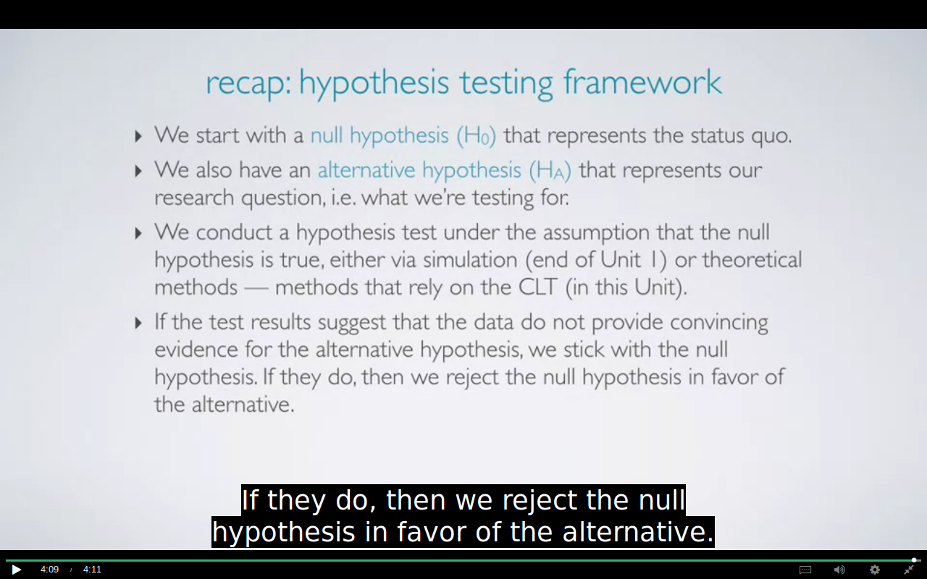

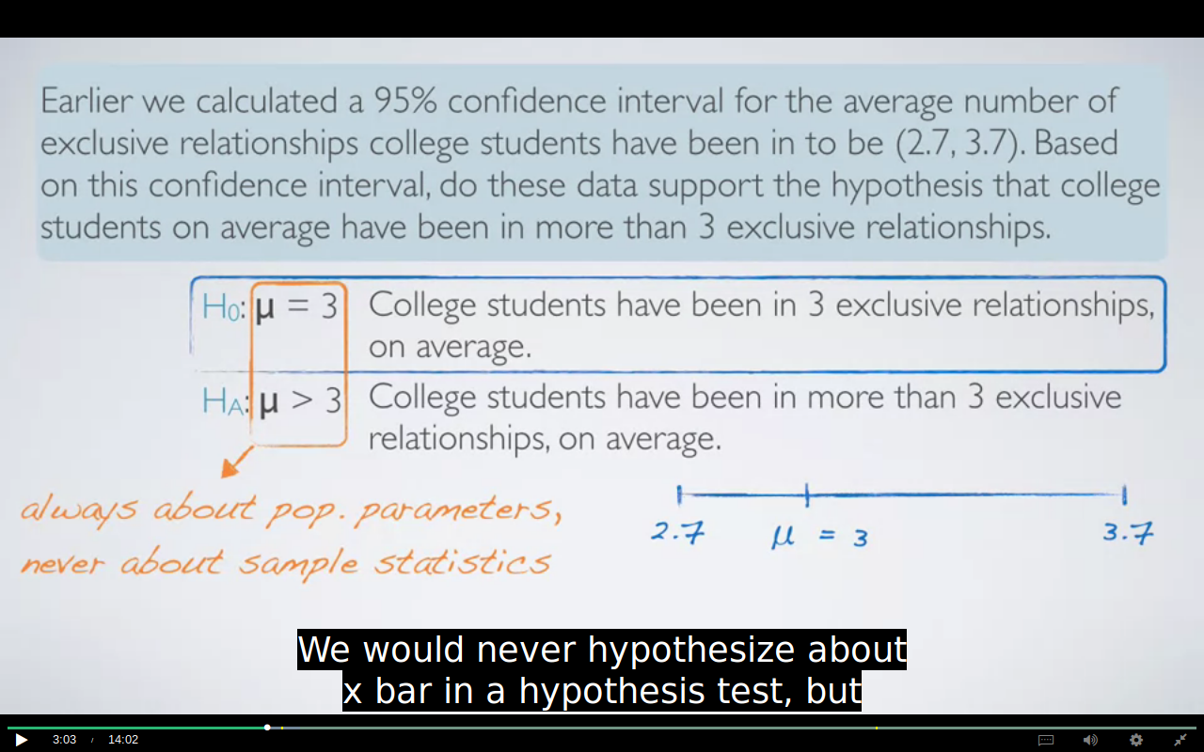
WE NEVER DO HYPOTHESIS TESTING FOR SAMPLE STATISTICS
IMPORTANT:

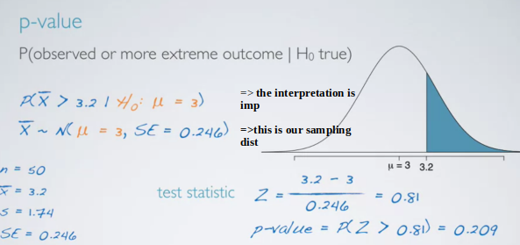
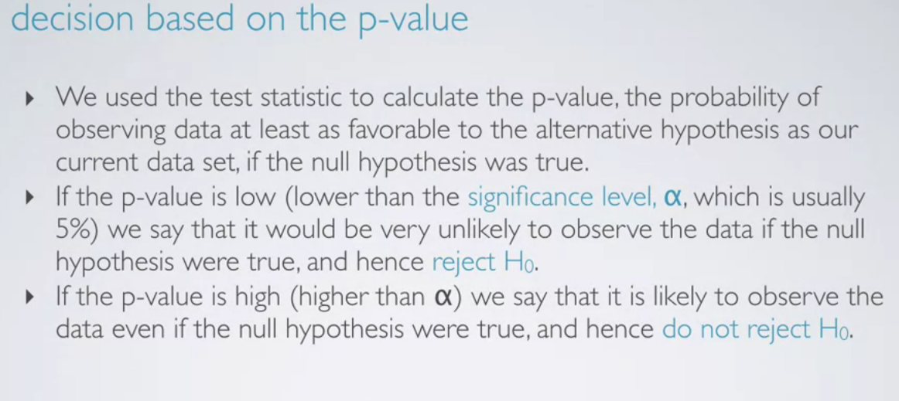
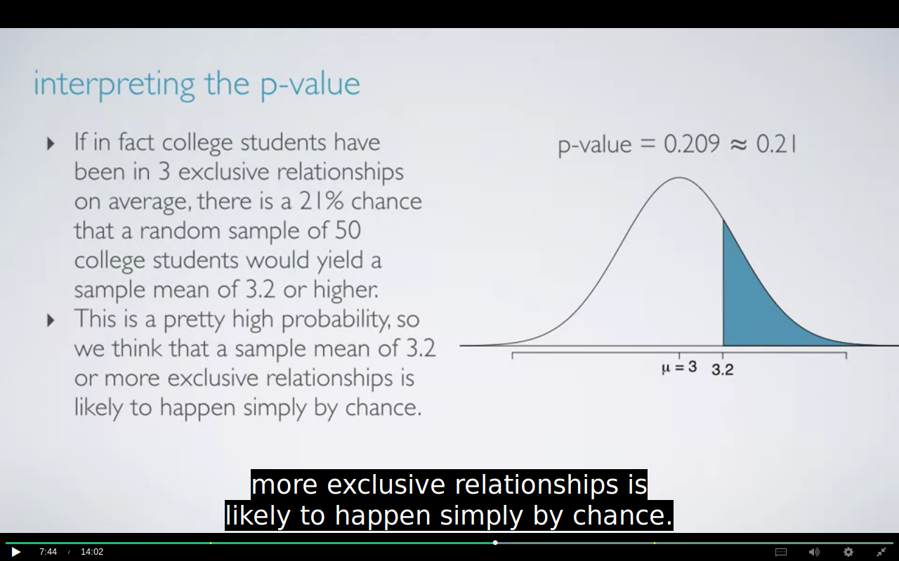

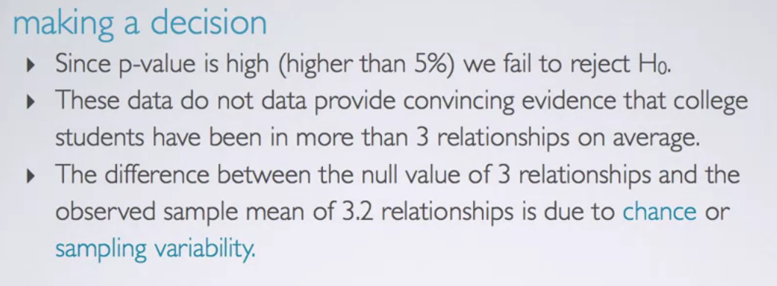
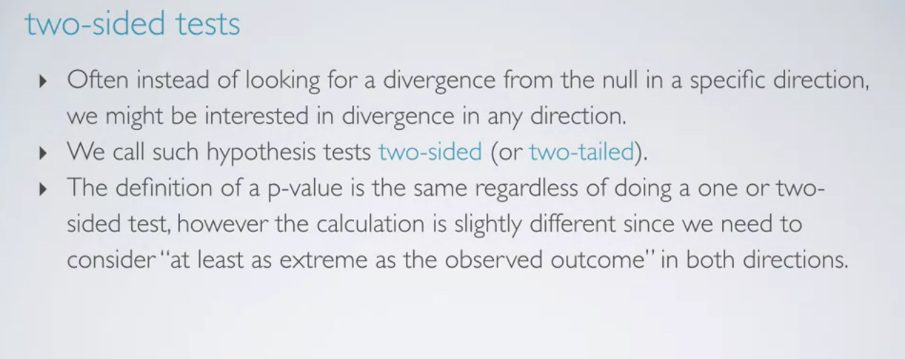
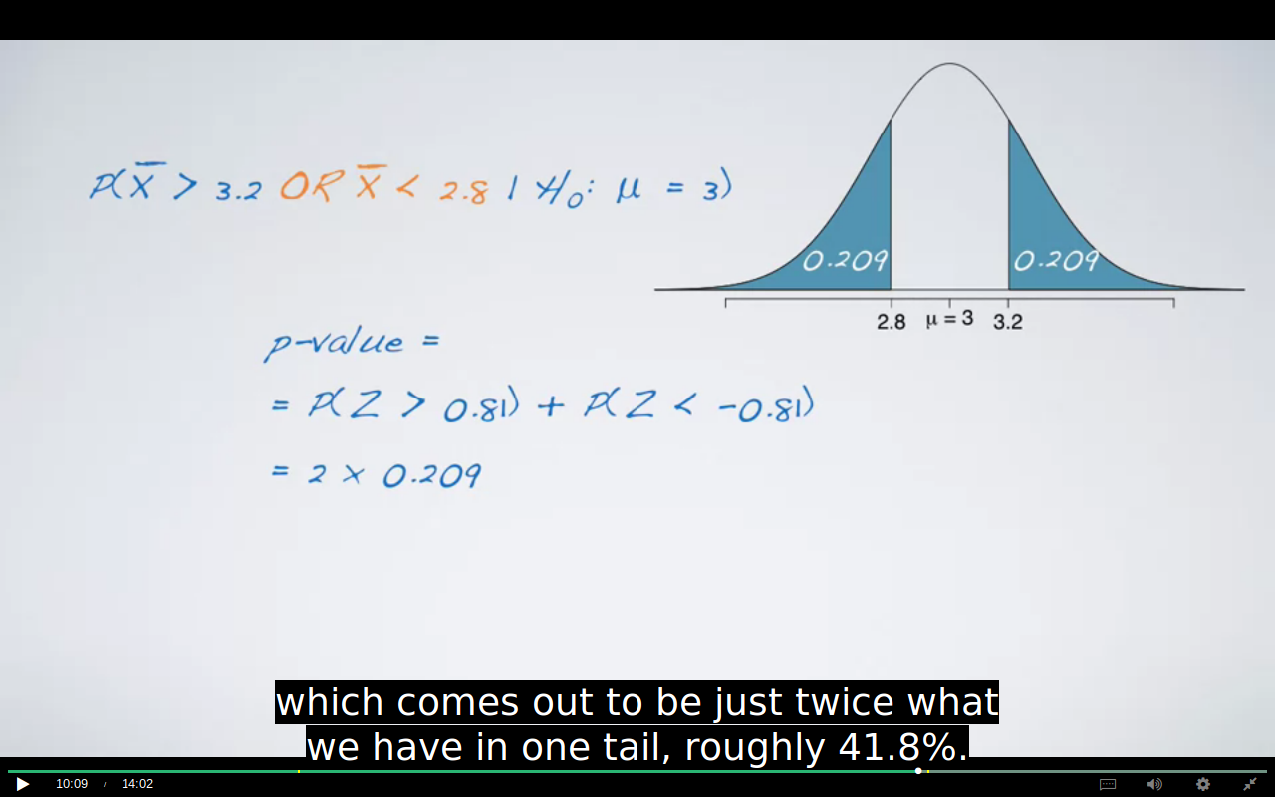

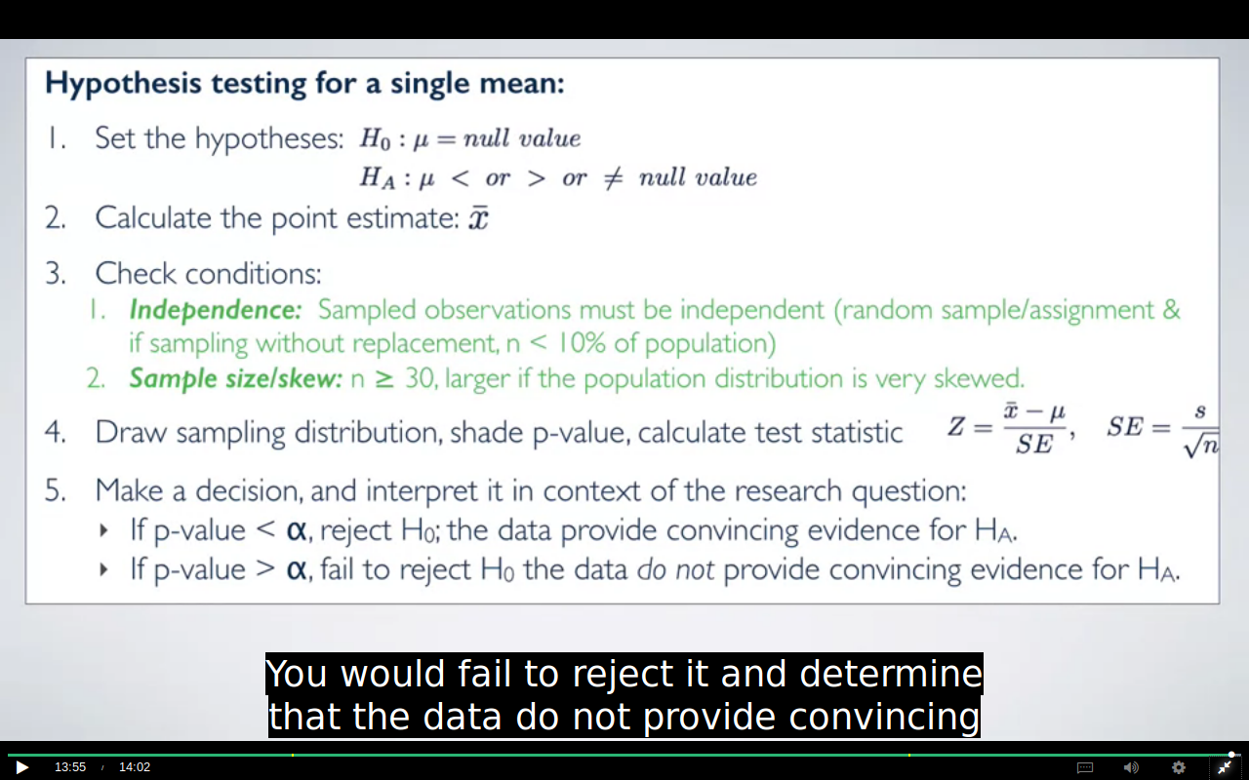
IMPORTANT QUESTION:

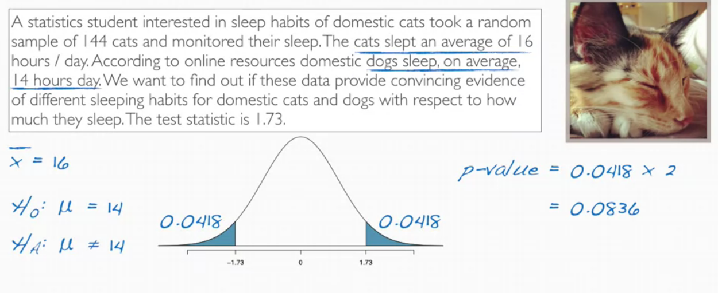

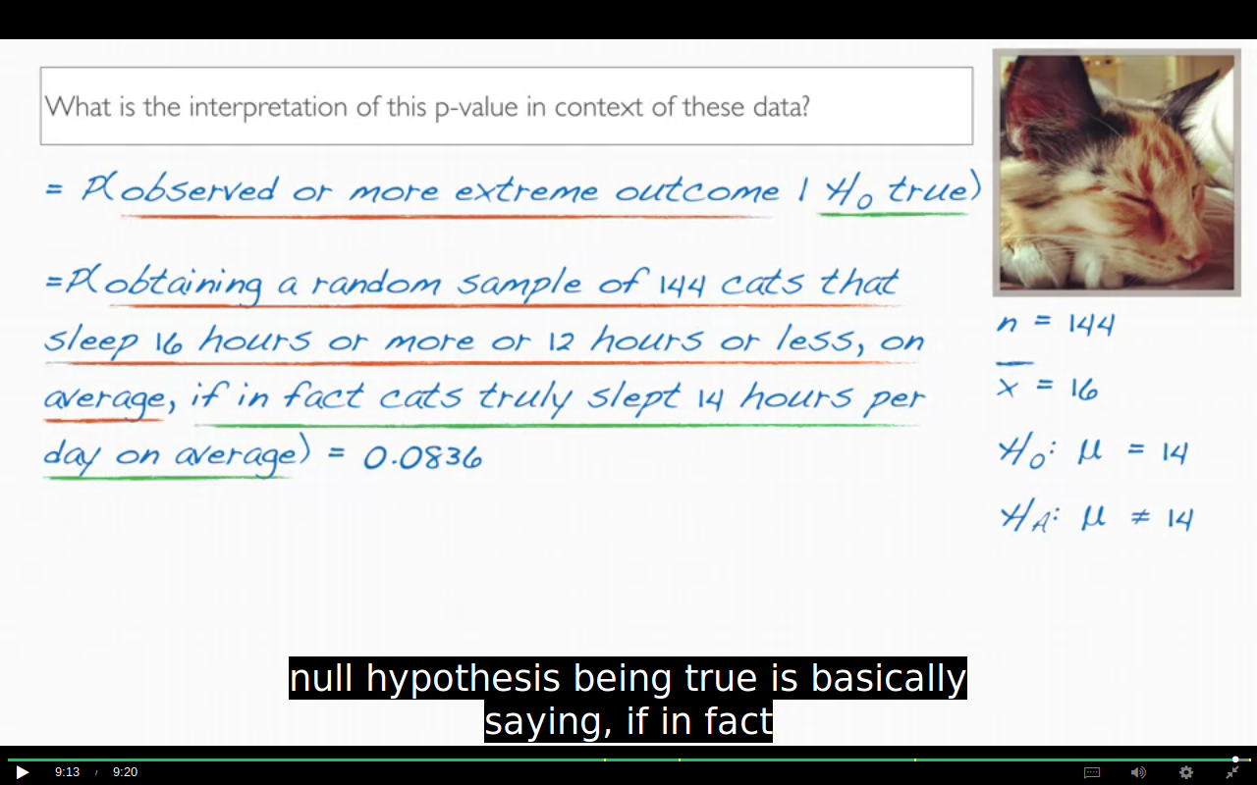
WEEK 3

In a nut shell, the t-distribution is useful for describing the distribution of the sample mean when the population standard deviation, sigma, is unknown,

if a std of pop is known and the sample size is less than 30 than we will still use Z distribution

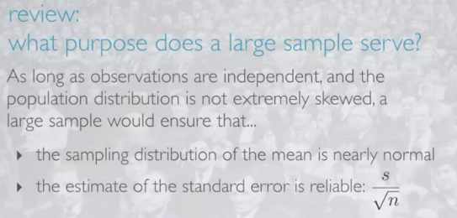

the uncertainty of the SE estimate is addressed by the t distribution which happens because of small sample size.

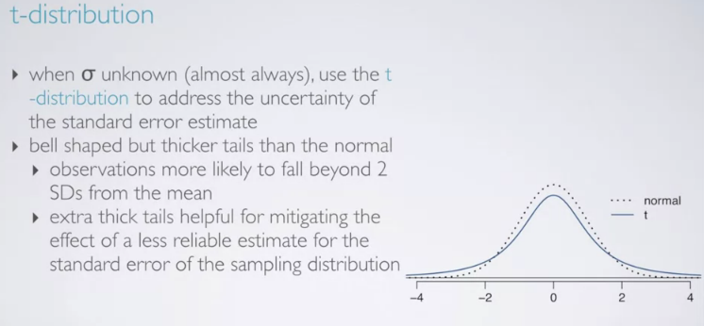

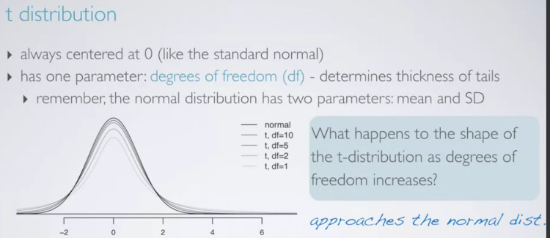
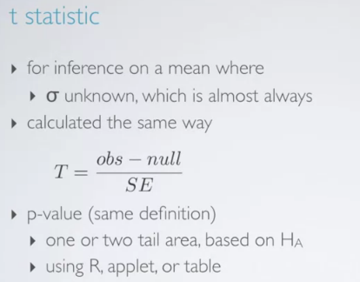

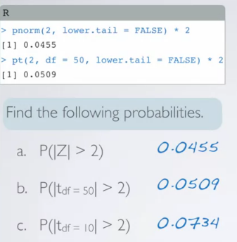
lower the df the harder it gets for the Ho to be rejected

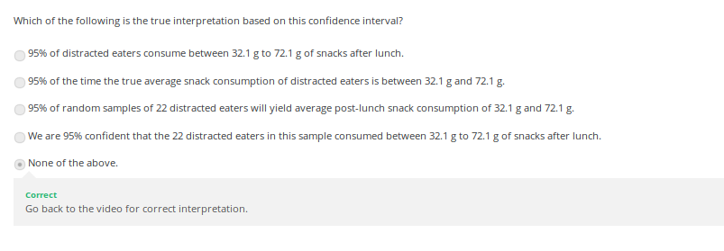
IMPORTANT

WE HAVEN’T TALKED ABOUT HOW CONFIDENT WE ARE IN THE ABOVE QUESTION EXCEPT THE LAST WHICH IS TALKING ABOUT THE SAMPLE
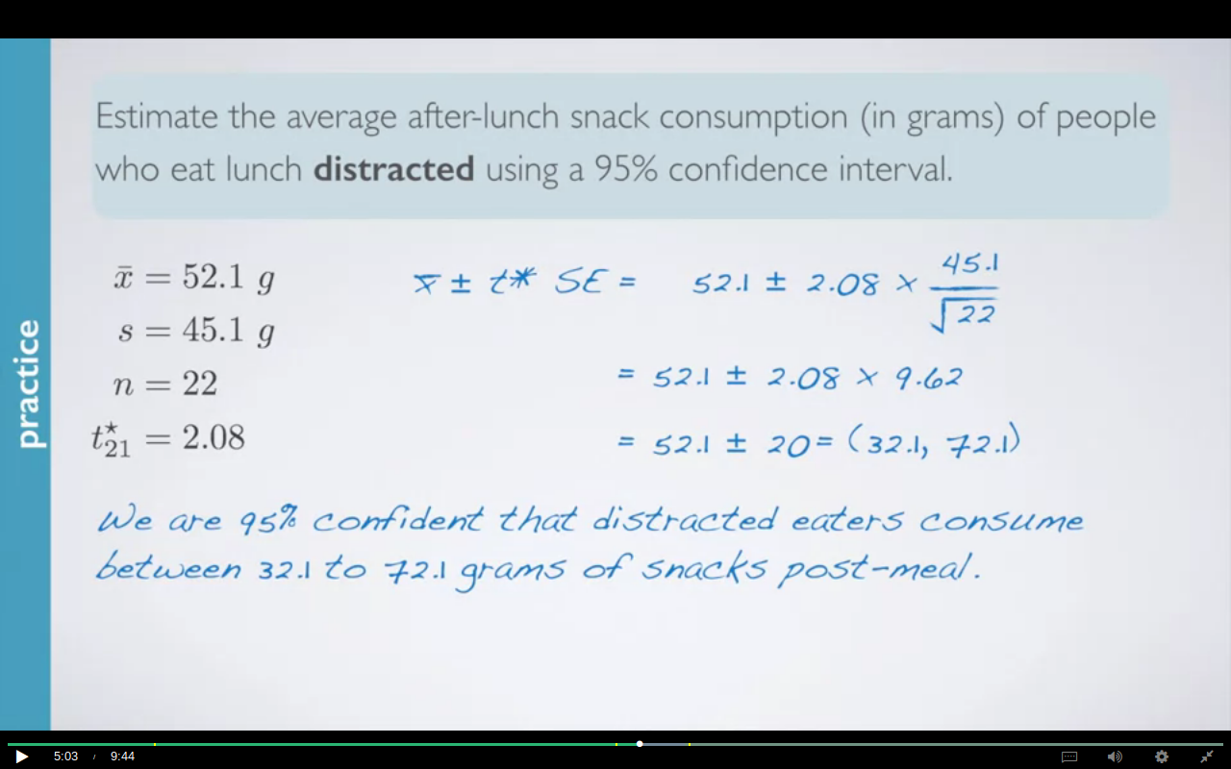
When you bring two unknowns together, the result should always be more variable,
regardless of whether you're adding them or subtracting them.

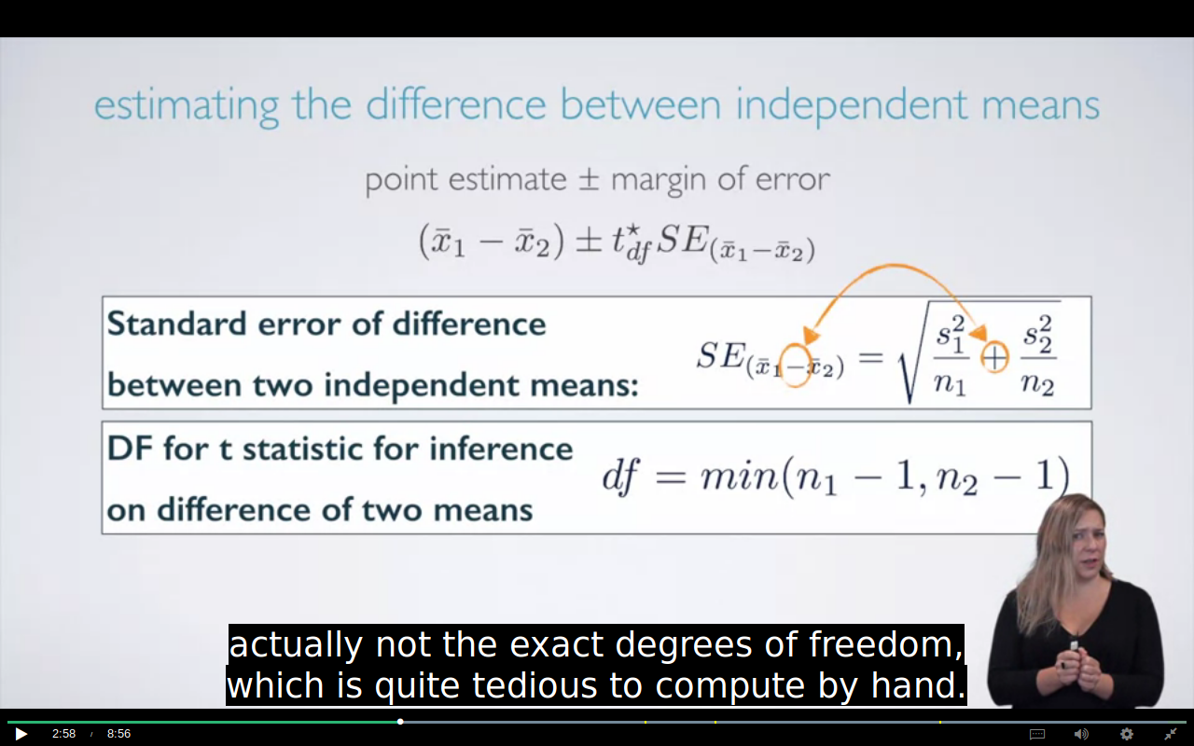
A conservative test always keep the probability of rejecting the null hypothesis well below the significance level. Let’s say you’re running a hypothesis test where you set the alpha level at 5%. That means that the test will (falsely) give you a significant result 1 out of 20 times. This is called the Type I error rate. A conservative test would always control the Type I error rate at a level much smaller than 5%, which means your chance of getting it wrong will be well below 5% (perhaps 2%).

minimum in calculating the df is basically setting our test ,conservative

if we are taking the df smaller the t distribution will have the wider hands and the probability of any observation lying within 95% of the data increases which lowers the chances of null hypothesis being rejected.

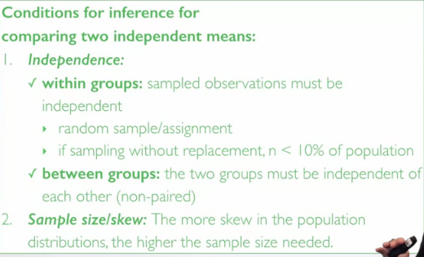

BOTH N1 and N2 should be the 10% of their respective population.

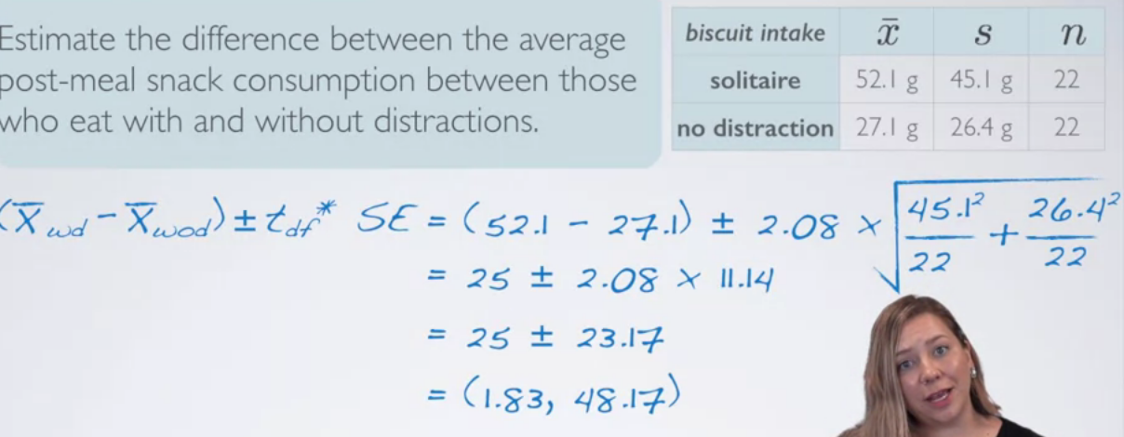

IMPORTANT:

Which of the following is the best interpretation for this interval?
We are 95% confident that…
A) the difference between the average snack consumption of those who eat with and without distractions is between 1.83 g and 48.17 g.
B) those who eat with distractions consume 1.83 g and 48.17 g more snacks than those who eat without distractions, on average.
Correct
The interpretation should indicate the direction of the relationship (i.e. which group is higher) and the difference between with and without distractions is positive.
C) those who eat with distractions consume 1.83 g and 48.17 g less snacks than those who eat without distractions, on average.
D) those who eat with distractions consume 1.83 g less to 48.17 g more snacks than those who eat without distractions, on average.
E) those who eat with distractions consume 1.83 g more to 48.17 g less snacks than those who eat without distractions, on average.95% of distracted eaters consume between 32.1 g to 72.1 g of snacks after lunch.

HYPOTHESIS TESTING FOR DIFF OF INDEPENDENT MEANS:
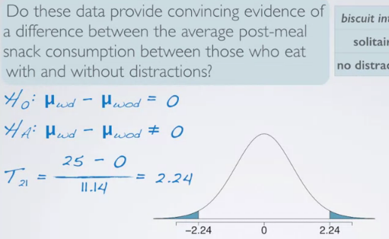

P VALUE: BETWEEN 0.02 AND 0.05
just because we observe a difference in the sample means,doesn't necessarily mean that there is something going on that is statistically significant in the actual populations. So, we use statistical inference tools to evaluate if this apparent relationship between distracted eating and snacking more provide evidence of a real difference at the population level. Note that we have a randomized control trial here, so if we do indeed find a significant result, we could then talk about a causal relationship between these two variables.

The confidence interval for the average difference was 1.83 to 48.17 and the hypothesis test
evaluating a different between the two means yielded a p-value of roughly 4%.
Which means that we would reject the null hypothesis and conclude that
these data do indeed provide convincing evidence that there is a difference
between the average snack intake of distracted and non-distracted eaters.

COMPARING PAIRED MEANS:
In situations where we do inference for pair data, most often the null hypothesis
sets the average difference between the two paired means equal to zero.
Indicating no difference between them.

Paired data can happen when we have a set of data from the same set of people.
Like in this case or in cases of pre-post studies.
A weight-loss study, for example, is a good example here.
The post-weight of an individual after a diet regimen
will necessarily be dependent on their pre-weight.
Other studies might also take repeated measures on the same set of people.
For example, you might measure reaction time of the same set of people after they
have spent the recommended amount of 7.5 hours the previous night or
if they've only spent two hours.
We might also use paired approaches when we have different sets of subjects to
begin with.
But for some reason these subjects we believe to be not independent.
Twin studies is an obvious example for these or studies on partner A and
partner B who are in a relationship.
We would design these studies as paired if we believe these individuals
in the two groups are similar on certain aspects and
we're evaluating their differences on other aspects.

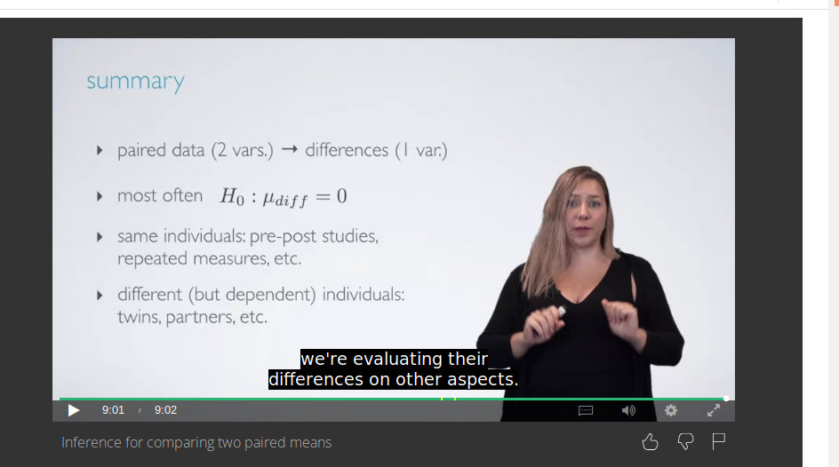

ANOVA:

we use anova to compare more than 2 means the null hypothesis says that there’s nothing going on all the means are same while the alternate says that at least one pair of mean are diff from each
other and doesn’t specifies which one.
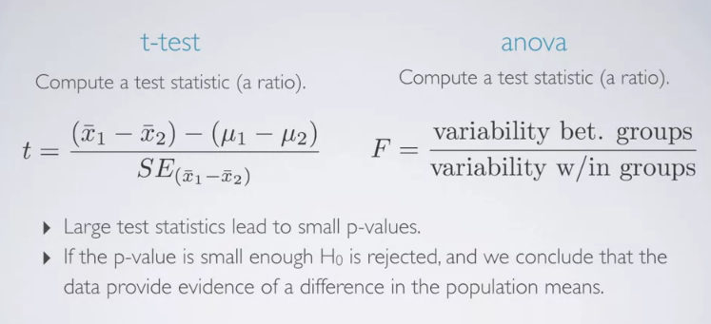
F DISTRIBUTION IS RIGHT SKEWED AND ALWAYS POSITIVE SINCE IT IS A RATIO OF VARIABILITY WHICH CAN NEVER BE NEGATIVE

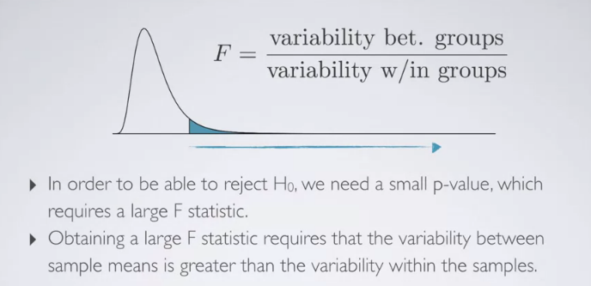

Which of the following is false about the independence condition for this analysis?
Remember, data source is the General Social Survey (GSS), and there are 41 participants in lower, 407 in working, 331 in middle, and 16 in upper class.
Random sampling condition can be assumed to be met since the GSS likely selects participants randomly.
Number of participants in each class are less than 10% of their respective populations.
We can assume that one participant in a given class is independent of another participant in that class with respect to their vocabulary score.
The groups are not independent since they come from the same sample of 795 participants who took the GSS.
Correct
The data for the groups come from the same survey, but this doesn’t mean the groups aren’t independent. Lack of independence would be caused by having a correspondence between people in the groups.



